Individual Retrospective

# Self-Assessment

## Achievement 1

Successfully collected, cleaned, and preprocessed datasets relevant to pedestrian foot traffic in Melbourne. This involved handling missing data, standardizing column names, and preparing the data for further analysis. My efforts have ensured that the data is ready for exploratory data analysis, which will be used to optimize urban infrastructure and improve pedestrian safety.

## Achievement 2

Organized the project repository on GitHub by creating branches and a playground folder, facilitating version control and collaborative development. This has streamlined the development process and allowed the team to work more efficiently.

Achievement 3

I have taken on significant leadership roles throughout the project, including volunteering as a GitHub pull request reviewer and hosting Week 7 activities. My contributions in these roles have ensured that the team's codebase remains consistent and high-quality, and that team discussions are well-organized and productive. Additionally, my involvement in preparing for INNOFES 2024 showcases my commitment to presenting our project to a broader audience and further developing my leadership skills through interaction with industry experts.

# Course Learning Outcomes

## GLO1 – Discipline-Specific Knowledge and Capabilities

* + I have developed a broad and coherent knowledge of data analytics by working on the data preprocessing phase of our project. This involved understanding the origin and characteristics of the data, applying methods to clean and prepare the data securely, and ensuring that the resulting datasets could be used to derive meaningful insights that contribute to improving urban infrastructure in Melbourne. These activities demonstrate my ability to apply advanced knowledge to real-world situations.

## GLO2 – Communication

* + I have communicated effectively with my team throughout the project, ensuring that all members were kept informed about the progress and next steps in our data preprocessing efforts. Additionally, I have volunteered to host Week 7, where I will facilitate discussions and coordinate tasks, demonstrating my ability to communicate in both technical and non-technical contexts.

## GLO3 – Digital Literacy

* + I have utilized a range of digital technologies, including GitHub for version control, Anaconda for managing project environments, and various data analysis tools. My contributions to organizing the project repository and managing branches on GitHub have enabled efficient collaboration and the effective dissemination of technical information.

## GLO4 – Critical Thinking

* + In working with complex datasets, I have employed critical and analytical thinking to appraise and address issues such as missing values and inconsistent column names. By doing so, I have ensured that the data is reliable and ready for analysis, which is crucial for uncovering patterns related to pedestrian traffic and footpath utilization in Melbourne.

## GLO5 – Problem Solving

* + I have applied my knowledge and critical analysis skills to solve the problem of incomplete and inconsistent data. By cleaning the data and standardizing columns, I developed solutions that ensure the datasets are suitable for further analysis. This work directly contributes to the project's goal of developing data-driven solutions for improving urban infrastructure.

## GLO6 – Self-Management

* + I have taken personal responsibility for my learning and project contributions by managing my time effectively and balancing project work with self-directed learning. Completing video lectures on GitHub, Anaconda, and GCL has strengthened my technical skills, allowing me to make more meaningful contributions to the project. Additionally, I have autonomously organized the project’s GitHub repository, demonstrating my ability to work independently and responsibly.

## GLO7 – Teamwork

* + As a GitHub pull request reviewer, I have worked both independently and collaboratively to maintain the quality and consistency of our codebase. This role required effective communication, negotiation, and conflict resolution skills, which I applied to ensure that all team contributions were aligned with the project’s objectives.

## GLO8 – Global Citizenship

* + The project’s aim of improving pedestrian safety and optimizing urban infrastructure reflects my commitment to global citizenship. By focusing on enhancing public spaces for diverse communities, I have demonstrated ethical behavior and accountability in the handling and analysis of data.

# SFIA Skills Associated with the Course

## Data Management (DATM)

* + I have demonstrated data management skills by overseeing the collection, cleaning, and preprocessing of datasets related to pedestrian traffic in Melbourne. My efforts ensured that the data was well-organized, accurate, and ready for further analysis, which is critical for deriving actionable insights.

## Data Modelling and Design (DATN)

* + While I have not yet fully engaged in data modeling and design, the work I have done in preparing the datasets lays the foundation for future modeling efforts. I anticipate that my contributions will support the creation of accurate models that can predict pedestrian behavior and guide urban planning decisions.

## Machine Learning (MLNG)

* My contributions to data preprocessing are essential for any machine learning applications that may follow. Clean and well-prepared data is crucial for training accurate and effective machine learning models. Although my direct involvement with machine learning is forthcoming, my current work supports these future efforts.
* I will also be participating in INNOFES 2024, which offers a prime opportunity to present my outstanding capstone City of Melbourne (CoM) Project to top tech industry leaders and recruiters. Preparation for INNOFES also provides an opportunity to develop key skills such as reasoning, ideation, and collaboration. This event will not only showcase the technical and leadership skills I have developed throughout this project but will also serve as a platform to gain valuable feedback from industry experts.

# Evidence:

**Git Commits to Personal and Company Repositories**: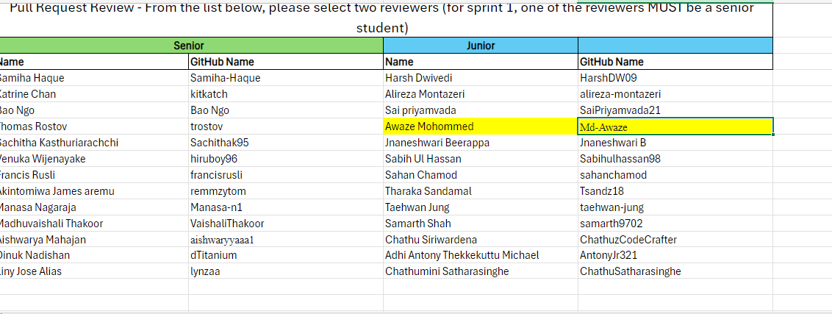

**Git Pull Requests**:

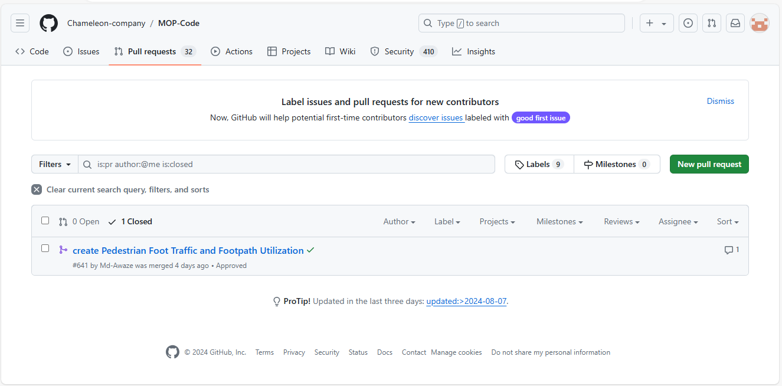

**Completion Certificates from Video Lectures**:

**GIT Repository Link:**

[MOP-Code/Playground/Awaze Mohommed/Pedestrian Foot Traffic and Footpath Utilization (4).ipynb at 34526fd877290f81d7bfb8fcb6166f5df779ba08 · Chameleon-company/MOP-Code (github.com)](https://github.com/Chameleon-company/MOP-Code/blob/34526fd877290f81d7bfb8fcb6166f5df779ba08/Playground/Awaze%20Mohommed/Pedestrian%20Foot%20Traffic%20and%20Footpath%20Utilization%20(4).ipynb)